Linux Directory Structure

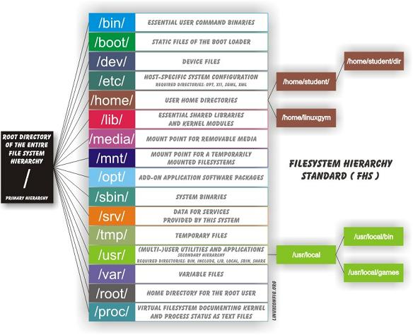

1. / (~) – Root  
   2. /bin – User Binaries  
   3. /sbin – System Binaries  
   4. /etc – Configuration Files (system defined)  
   5. /dev – Device Files  
   6. /proc – Process Information  
   7. /var – (installation) Variable Files (user installation)  
   8. /tmp – Temporary Files  
   9. /usr – User Programs  
   10. /home – Home Directories  
   11. /boot – Boot Loader Files (auto start any application and services)  
   12. /lib – System Libraries  
   13. /opt – Optional add-on Applications  
   14. /mnt – Mount Directory  
   15. /media – Removable Media Devices  
   16. /srv – Service Data
2. / – Root  
     
   The root directory. The starting point of your directory structure. This is where the Linux system begins. Every other file and directory on your system is under the root directory. Usually the root directory contains only subdirectories, so it’s a bad idea to store single files directly under root.Only root user has write privilege under this directory.Please note that /root is root user’s home directory, which is not same as / .  
     
   you can go inside root directory via  
     
   *# cd /*
3. 2. /bin – User Binaries, /usr/bin  
     
   These two directories contain a lot of programs (binaries, hence the directory’s name) for the system. Common linux commands you need to use in single-user modes are located under this directory.The /bin directory contains the most important programs that the system needs to operate, such as the shells, ls, grep, and other essential things For example: ps, ls, ping, grep, cp. /usr/bin in turn contains applications for the system’s users. However, in some cases it really doesn’t make much difference if you put the program in /bin or /usr/bin.
4. 3. /sbin – System Binaries  
     
   Most system administration programs are stored in these directories. In many cases you must run these programs as the root user.For example: iptables, reboot, fdisk, ifconfig, swapon. It also contains binary executables you can check by
5. 4. /etc – Configuration FilesThe configuration files for the Linux system.It contains configuration files required by all programs Most of these files are text files and can be edited by hand. Some interesting  
   stuff in this directory:
6. 5. /dev – Device Files  
     
   The devices that are available to a Linux system. Remember that in Linux, devices are treated like files and you can read and write devices like they were files. For example, */dev/fd0* is your first floppy drive, */dev/cdrom* is your CD drive, /dev/hda is the first IDE hard drive, and so on. All the devices that a Linux kernel can understand are located under */dev*, and that’s why it contains hundreds of entries.These include terminal devices, usb, or any device attached to the system.Example */dev/tty1, /dev/usbmon0*
7. 6. /proc – Process Information  
     
   This is a special directory. Well, actually */proc*is just a virtual directory, because it doesn’t exist at all! It contains some info about the kernel itself. There’s a bunch of numbered entries that correspond to all processes running on the system, and there are also named entries that permit access to the current configuration of the system. Many of these entries can be viewed.by *#cd* /proc and then type *#ls*This is a pseudo filesystem contains information about running process. For example: /proc/{pid} directory contains information about the process with that particular pid.Last but not least it Contains information about system process.
8. 7. /var – Variable Files  
     
   This directory contains variable data that changes constantly when the system is running.
9. 8. /tmp – Temporary Files  
     
   Programs can write their temporary files here.
10. 9. /usr – User Programs  
      
    This directory contains user applications and a variety of other things for them, like their source codes, and pictures, docs, or config files they use. */usr* is the largest directory on a Linux system, and some people like to have it on a separate partition. Some interesting stuff in */usr*
11. 10. /home – Home Directories  
      
    This is where users keep their personal files. Every user has their own directory under */home*, and usually it’s the only place where normal users are allowed to write files. You can configure a Linux system so that normal users can’t even list the contents of other users’ home directories. This means that if your family members have their own user accounts on your Linux system, they won’t see all the w4r3z you keep in your home directory.
12. 11. /boot – Boot Loader FilesAs the name suggests, this is the place where Linux keeps information that it needs when booting up. For example, this is where the Linux kernel is kept. If you list the contents of */boot*, you’ll see a file called vmlinuz – that’s the kernel.Kernel initrd, vmlinux, grub files are located under */boot* For example: initrd.img-2.6.32-24-generic, vmlinuz-2.6.32-24-generic
13. 12. /lib – System Libraries  
      
    The shared libraries for programs that are dynamically linked. The shared libraries are similar to DLL’s on Winblows
14. 13. /opt – Optional add-on Applications  
      
    opt stands for optional.Contains add-on applications from individual vendors.add-on applications should be installed under either /opt/ or /opt/ sub-directory
15. 14. /mnt – Mount Directory  
      
    Temporary mount directory where sysadmins can mount filesystems.This directory is used for mount points. The different physical storage devices (like the hard disk drives, floppies, CD-ROM’s) must be attached to some directory in the file system tree before they can be accessed. This attaching is called mounting, and the directory where the device is attached is called the mount point.The /mnt directory contains mount points for different devices, like*/mnt/*floppy for the floppy drive, */mnt/cdrom*for the CD-ROM, and so on. However, you’re not forced to use the */mnt* directory for this purpose, you can use whatever directory you wish. Actually in some distros, like Debian and SuSE, the default is to use */floppy* and */cdrom* as mount points instead of directories under */mnt*
16. 15. /media – Removable Media Devices  
      
    Temporary mount directory for removable devices.For examples, /media/cdrom for CD-ROM; /media/floppy for floppy drives; /media/cdrecorder for CD writer
17. 16./srv – Service Data  
      
    srv stands for service.Contains server specific services related data.For example, /srv/cvs contains CVS related data.